**Using node JS**

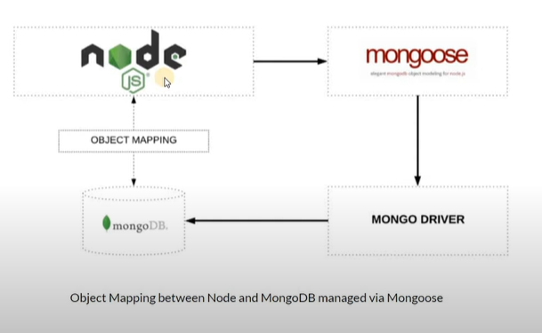

So to connect between node and mongodb an application layer called as mongoose is used.

It is an odm (object data mapping) library for both node and mongo db.

The objects in node are converted to documents with the help of ODM

So first need to setup an environment for mongo db .

🡪Create a separate folder named as mongodb

🡪create another folder as mongooseJS

🡪create another folder as src which is source

🡪Inside source create a file app.js

🡪first before installing mongoose create a package.JSON file. This will keep the track of all the packages u have/will installed.

🡪Run the command in mongodb folder so that its applicable to entire system.

Command: npm init – y

🡪now to download mongoose library use cd and go inside the main folder.

🡪The sub main folder is main eye of the entire process ie in this case mongooseJS folder

🡪npm install mongoose. This will create a node js modules and package lock.json files.

After installing mongoose

First creat an object to fetch the module functions.

Const mongoose=require(‘mongoose’)

mongoose.connect(“mongodb://localhost:27017/dbname)

To know if its succefully connected or not , lets have a try catch concept

mongoose.conect(“mongodb://localhost:27017/dbname).then( ()=>console.log(“message”).catch( (error)=>console.log(error))

here localhost port by default of a mongo db is 27017 and dbname if exist will use the same otherwise creates a new db.